For each of the following truth tables, write the disjunctive normal of the equation.

Table 1 | x | y | 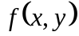
 | 1 | 1 | 1
 | 1 | 0 | 1
 | 0 | 1 | 0
 | 0 | 0 | 1

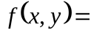

Table 2-3 | x | y | z | 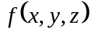
 | 1 | 1 | 1 | 0
 | 1 | 1 | 0 | 1
 | 1 | 0 | 1 | 0
 | 1 | 0 | 0 | 1
 | 0 | 1 | 1 | 1
 | 0 | 1 | 0 | 0
 | 0 | 0 | 1 | 1
 | 0 | 0 | 0 | 1

=

Table 4-5 | x | y | z
 | 1 | 1 | 1 | 1
 | 1 | 1 | 0 | 1
 | 1 | 0 | 1 | 0
 | 1 | 0 | 0 | 1
 | 0 | 1 | 1 | 0
 | 0 | 1 | 0 | 1
 | 0 | 0 | 1 | 0
 | 0 | 0 | 0 | 1

=

Table 6-7 | W | x | y | Z | 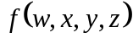
 | 1 | 1 | 1 | 1 | 0
 | 1 | 1 | 1 | 0 | 1
 | 1 | 1 | 0 | 1 | 1
 | 1 | 1 | 0 | 0 | 1
 | 1 | 0 | 1 | 1 | 0
 | 1 | 0 | 1 | 0 | 0
 | 1 | 0 | 0 | 1 | 1
 | 1 | 0 | 0 | 0 | 1
 | 0 | 1 | 1 | 1 | 0
 | 0 | 1 | 1 | 0 | 0
 | 0 | 1 | 0 | 1 | 0
 | 0 | 1 | 0 | 0 | 1
 | 0 | 0 | 1 | 1 | 1
 | 0 | 0 | 1 | 0 | 1
 | 0 | 0 | 0 | 1 | 0
 | 0 | 0 | 0 | 0 | 0

=

For each of the following Boolean functions, write the expression in disjunctive normal form.

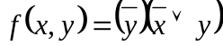

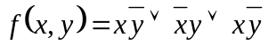

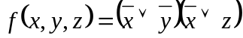

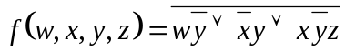

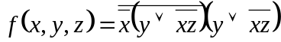

III.
Write each decimal number in a 6-bit 2s complement representation. |  | Write each decimal number in a 5-bit 2s complement representation. What do you bubble on scantron?
29 = |  | -15 = | ABCDE
13 = |  | -13 = | ABCDE
6 = |  | -6 = | ABCDE
0 = |  | -1 = | ABCDE
-4 = |  | 0 = | ABCDE
-19 = |  | 4 = | ABCDE
-27 = |  | 11 = | ABCDE
-32 = |  | 14 = | ABCDE

Perform the following 2s complement addition problems using 4-bit arithmetic. What would you bubble if the answer is zero? Would you ever bubble A only?

1101 1010 0101 1001
+1011 +1101 +1010 +0111
ABCDE ABCDE ABCDE ABCDE

Half Adders

Half adder | x | y | c | s
 | 1 | 1
 | 1 | 0
 | 0 | 1
 | 0 | 0

Write the Boolean function for c in a half adder: c = ___________________________
Write the Boolean function for s in a half adder: s = ___________________________
Full Adder

Write the Boolean function for c in a full adder: c = ___________________________
Write the Boolean function for s in a full adder: s = ___________________________

Full adder | x | y | z | c | s
 | 1 | 1 | 1
 | 1 | 1 | 0
 | 1 | 0 | 1
 | 1 | 0 | 0
 | 0 | 1 | 1
 | 0 | 1 | 0
 | 0 | 0 | 1
 | 0 | 0 | 0

NAND Implementations:
Draw the NAND implementation for each of the following

NOT | AND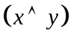

OR 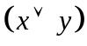 | 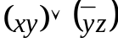 /* Do not forget to simplify */

